1. **Class - Movie**

The class Movie is stated below. An instance of class Movie represents a film. This class has the following three properties:

* title, which is a String representing the title of the movie
* studio, which is a String representing the studio that made the movie
* rating, which is a String representing the rating of the movie (i.e. PG­13, R, etc)

a) Write a constructor for the class Movie, which takes a String representing the title of the movie, a String representing the studio, and a String representing the rating as its arguments, and sets the respective class properties to these values.

b) The constructor for the class Movie will set the class property rating to "PG" as default when no rating is provided.

c) Write a method getPG, which takes an array of base type Movie as its argument, and returns a new array of only those movies in the input array with a rating of "PG". You may assume the input array is full of Movie instances. The returned array need not be full.

d) Write a piece of code that creates an instance of the class Movie with the title “Casino Royale”, the studio “Eon Productions”, and the rating “PG­13”

**Solution:**

class movie{

    constructor(title,studio,rating){

        this.title=title;

        this.studio=studio;

        this.rating=rating;

    }

}

var m1=new movie("Casino Royale","Eon Productions",getPG(arr));

var arr=[];

function getPG(arr){

    return ["PG13","R"];

}

console.log(m1.title+" "+m1.studio+" "+m1.rating);

**Output**: Casino Royale Eon Productions PG13,R

# Circle - Class

Convert the UML diagram to Typescript class. - use number for double

[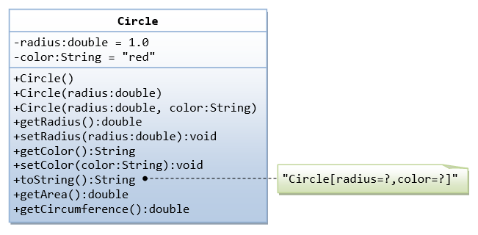](https://github.com/rvsp/typescript-oops/blob/master/images/ClassDiagram_Circle.png)

Solution:

class Circle{

    constructor(radius,color){

        this.radius=radius;

        this.color=color;

    }

}

var c1=new Circle(1.0,"red");

function circle(radius){

    return radius;

}

console.log(circle(c1.radius));

function circle(radius,color){

    return radius+" "+color

}

console.log(circle(c1.radius,c1.color));

function getRadius(radius){

    return radius;

}

console.log(getRadius(c1.radius));

function setRadius(radius){

    return radius;

}

console.log(setRadius(2.0));

function getColor(color){

    return color;

}

console.log(getColor(c1.color));

function setColor(color){

    return color;

}

console.log(setColor("blue"));

function toString(radius,color){

    return radius+" "+color;

}

console.log(toString("1.0","red"));

function getArea(radius){

    var A=3.14*radius;

    return A;

}

console.log(getArea(c1.radius));

function getCircumference(radius){

    var A=2*3.14*radius;

    return A;

}

console.log(getCircumference(c1.radius));

Output:

1

1 red

1

2

Red

Blue

1. red

3.14

6.28

1. **Write a “person” class to hold all the details.**

**Solution:**

class Person{

    constructor(firstname,lastname,age,phonenumber,clg,dept,address){

        this.firstname=firstname;

        this.lastname=lastname;

        this.age=age;

        this.phonenumber=phonenumber;

        this.clg=clg;

        this.dept=dept;

        this.address=address;

    }

}

var p1=new Person();

p1.firstname="Vijay";

p1.lastname="kumar";

p1.age=23;

p1.phonenumber=9876543210;

p1.clg="PSG";

p1.dept="CSE";

p1.address="SELAM";

console.log(p1.firstname+" "+p1.lastname+" "+p1.age+" "+p1.phonenumber+" "+p1.clg+" "+p1.dept+" "+p1.address);

**Output:** Vijay kumar 23 9876543210 PSG CSE SELAM

1. **write a class to calculate uber price.**

**Solution:**

class uberPrice{

    constructor(firstmile,lastmile,numofseats,phoneno,productno,perkmprice,totalprice,location){

        this.firstmile=firstmile;

        this.lastmile=lastmile;

        this.numofseats=numofseats;

        this.phoneno=phoneno;

        this.productno=productno;

        this.perkmprice=perkmprice;

        this.totalprice=totalprice;

        this.location=location;

    }

}

var p1=new uberPrice();

    p1.firstmile=2;

    p1.lastmile=5;

    p1.numofseats=3;

    p1.phoneno=9876543201;

    p1.productno="#nahdg@jabfdsdjb&887122@njnjdnw2";

    p1.perkmprice=10

    p1.totalprice=70;

    p1.location="Kindy";

console.log(p1.firstmile+" "+p1.lastmile+" "+p1.numofseats+" "+p1.phoneno+" "+p1.productno+" "+p1.perkmprice+" "+p1.totalprice+" "+p1.location);

**Output:**

2 5 3 9876543201 #nahdg@jabfdsdjb&887122@njnjdnw2 10 70 Kindy